An Investigation into the Primary Psychological Drivers Shaping Blind Box Consumption Among Students at CUHK-Shenzhen

Abstract
Blind box consumption has rapidly evolved into a global cultural phenomenon, yet the relative importance and dynamic interplay of psychological drivers underlying the behavior remain underexplored. This study investigates these mechanisms among CUHK-Shenzhen students using a sequential mixed-methods design. Quantitative analysis identifies Uncertainty Appeal as the dominant driver, followed by Collection Satisfaction and Social Identity Expression. Cluster analysis further distinguishes three consumer segments: Holistic Enthusiasts, Thrill Seekers, and Passive Consumers. Complementing these quantitative findings, qualitative insights reveal a dynamic “Thrill-Control-Connection” trajectory, demonstrating that while uncertainty initiates consumption, collection satisfaction and social identity are critical for habituation and sustainment. Practically, this study advocates leveraging uncertainty mechanics for customer acquisition, while fostering collection satisfaction and community bonding to ensure long-term retention.
Keywords: Blind Box Consumption, Uncertainty Appeal, Collection Satisfaction, Social Identity Expression

Introduction and Literature Review
The blind box consumption model, in which consumers purchase a sealed package containing an unknown collectible, has rapidly evolved from a niche hobby into a global cultural phenomenon, exemplified by the multi-billion-dollar success of companies like Pop Mart. This model’s powerful grip on modern youth culture suggests its appeal is rooted not only in the product’s tangible value but in a sophisticated network of psychological drivers that foster both initial purchase and sustained engagement (Wei & Yu, 2025). In seeking to understand these drivers, existing literature has largely advanced along two distinct lines: individual-centered psychological mechanisms and broader socio-cultural influences.
One prominent stream of research focuses on internal psychological drivers, notable among which is the allure of uncertain rewards. Xia et al. (2025) emphasize uncertainty appeal as a primary, standalone catalyst for consumer engagement. This intense motivation—often greater than for predictable outcomes (Zhang et al., 2017)—is rooted in neurobiology: the brain releases dopamine specifically during reward anticipation rather than receipt (Schultz, 2016). Furthermore, the intrinsic desire to collect emerges as another key psychological driver. Consumers derive significant pleasure from completing sets and acquiring rare items, a behavior that satisfies an intrinsic need for order and control (Cao et al., 2025).
Complementing individual drivers, a second stream of research highlights socio-cultural forces, framing blind box consumption as a practice rooted in identity and community. Within fan communities, the blind boxes transcend utility function to become badges of membership and a form of social currency (Zhang & Li, 2022; Rogova & Matta, 2022), embodying status, taste, and shared meaning (Wolter et al., 2015). Putting this theory into practice, empirical work on blind-box markets by Liu et al. (2023) confirms that the identity motives and community dynamics, rather than solely hedonic surprise, are what truly drive sustained engagement.
While individual-centered and socio-cultural drivers offer crucial insights, they remain predominantly isolated in existing literature, obscuring a holistic understanding of their relative importance and dynamic interplay. To address this gap, two research questions are put forward:
RQ1: What is the hierarchy of psychological drivers motivating blind box consumption among CUHK-Shenzhen students?
RQ2: How does the interplay of these drivers evolve dynamically throughout the consumer journey?

Methods
Utilizing a sequential mixed-methods design, this study employed quantitative surveys to rank dominant psychological drivers, followed by qualitative interviews to explore the evolution of these drivers throughout the consumer journey.
Participants
Targeting CUHK-Shenzhen students, Phase 1 recruited 80 participants with verified purchase history. Phase 2 utilized purposive sampling (Patton, 2015) to select five "information-rich" interviewees (P01–P05) based on regular consumption (at least four purchases in six months) and demographic diversity. As detailed in Table 1, the cohort included three females and two males, spanning from a first-year undergraduate to a third-year doctoral student, ensuring a broad spectrum of consumption habits.
Table 1
Demographics and Consumption Habits of Interviewees
Participant Code | Gender | Student Status | Blind Box Purchases (Past 6 Months)
P01 | Female | Undergraduate, Year 2 | 6
P02 | Male | Undergraduate, Year 3 | 5
P03 | Female | PhD Student, Year 3 | 6
P04 | Male | Undergraduate, Year 2 | 4
P05 | Female | Undergraduate, Year 1 | 4

Data Collection
Data collection was executed in two sequential phases. First, an online questionnaire quantitatively assessed psychological drivers, specifically Uncertainty Appeal, Collection Satisfaction, and Social Identity Expression. Grounded in consumer psychology literature, each concept was measured via four-item scales on a 6-point Likert system, with a trap question embedded to ensure data integrity. Subsequently, five semi-structured interviews explicated quantitative findings by probing motivational evolution throughout the consumer journey. Each interview, lasting approximately 10 minutes, was conducted in the participant’s mother tongue, audio-recorded with consent, and transcribed by the author.
Data Analysis
In the quantitative phase, rigorous preprocessing first reduced the initial 80 responses to a final valid sample of 76. Subsequently, Cronbach’s Alpha was computed, confirming high internal consistency across all constructs (α > 0.80). With data quality established, descriptive statistics—specifically individual item and composite mean scores—were computed to hierarchically rank the drivers. Then, K-means cluster analysis was conducted to segment participants based on consumption patterns. A three-cluster solution was ultimately adopted as it yielded the highest average silhouette score, confirming it as the most robust model. In the qualitative phase, interview transcripts were translated into English and subjected to rigorous inductive thematic analysis (Braun & Clarke, 2006). This iterative process involved systematic coding, the identification of candidate themes and sub-themes, and a final comparative synthesis to crystallize dominant narratives.

Results
Quantitative Findings: The Hierarchy of Drivers
The quantitative analysis established a clear motivational hierarchy. As illustrated in Figure 1, Uncertainty Appeal emerged as the primary driver (Mean=4.15), followed by Collection Satisfaction (Mean=3.75). In contrast, Social Identity Expression (Mean=2.94) received the lowest scores, indicating a less explicit recognition of social factors among participants.
Figure 1
Mean Scores of Psychological Drivers at Item and Category Levels
Note: Bars represent mean scores for individual scale items. Dashed lines indicate the aggregate mean score for each construct (Uncertainty Appeal = 4.15; Collection Satisfaction = 3.75; Social Identity Expression = 2.94).
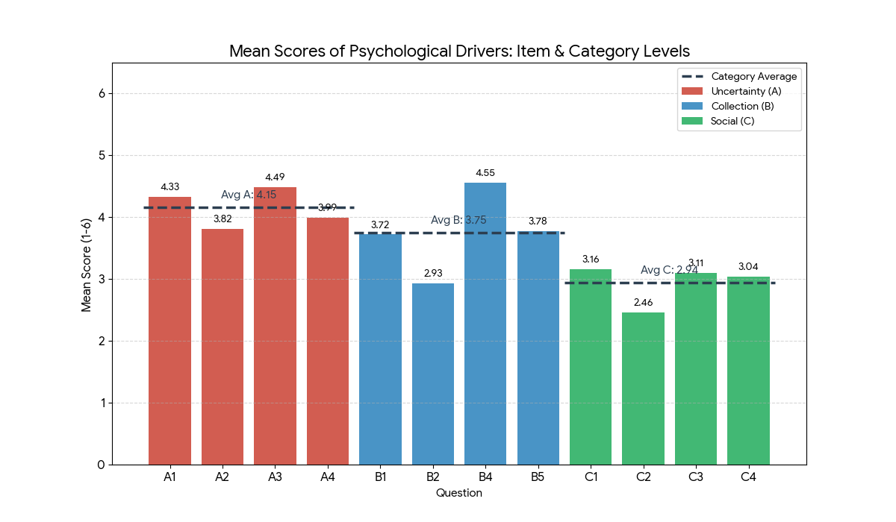

Additionally, the K-Means clustering segmented the participants into three distinct consumer personas (Figure 2).
Figure 2
3D Visualization of Consumer Segments Based on Psychological Drivers
Note: The scatter plot illustrates the separation of three identified clusters based on their scores on Uncertainty Appeal, Collection Satisfaction, and Social Identity Expression. Colors represent the distinct personas: Passive Consumers (Red), Thrill Seekers (Blue), and Holistic Enthusiasts (Green).
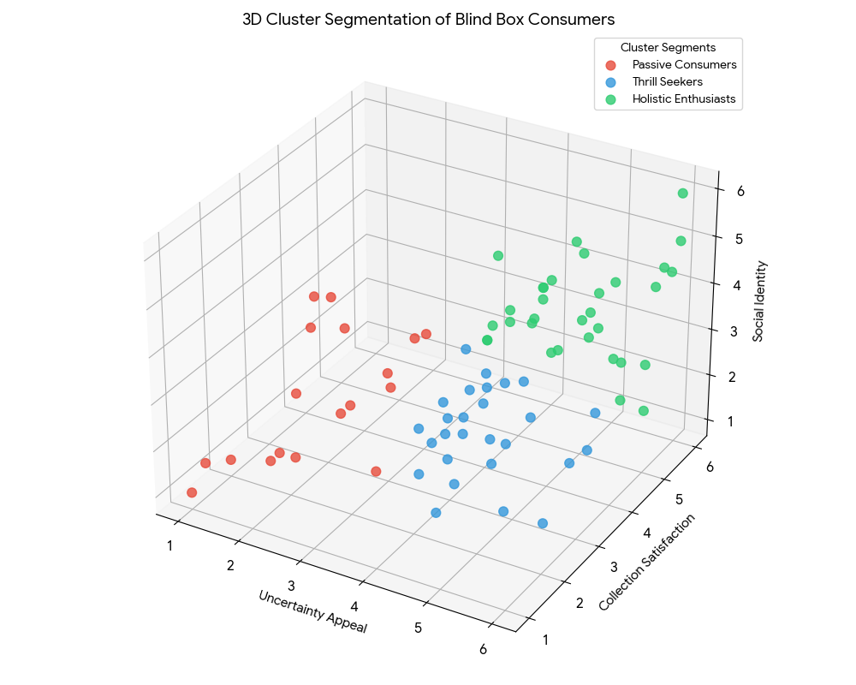

The largest segment, labeled Holistic Enthusiasts (41.6%), exhibited exceptionally high mean scores across all dimensions (Uncertainty=5.0, Collection=4.9, Social=3.9), representing core users driven by a holistic combination of thrill, completion, and community. A second distinct group, Thrill Seekers (35.1%), was characterized by high uncertainty appeal (Mean=4.5) but only moderate collection satisfaction (Mean=3.1) and low social identity scores (Mean=2.2). This segment appeared to seek the momentary physiological arousal of “unboxing” rather than long-term ownership or social validation. The final cluster, Passive Consumers (23.4%), reported consistently low mean scores ranging from 2.1 to 2.6 across all three metrics, indicating a profile of indifference with minimal psychological engagement.
Qualitative Findings: The Evolution of Motivation
Contrasting with the static quantitative hierarchy, inductive thematic analysis revealed that the consumer journey follows a dynamic “Thrill-Control-Connection” trajectory comprising three distinct phases: Initiation, Habituation, and Sustainment.
Initiation is driven by Uncertainty Appeal, acting as a physiological hook. P05 described a sensory compulsion (“hands itching”), while P02 cited a “gambling thrill,” deriving value from the acquisition process rather than the object itself.
Motivation subsequently shifts to Habituation, where Collection Satisfaction imposes order on chaotic uncertainty. P01 and P03 attempted to mitigate “incompleteness” through technical mastery—such as weighing boxes—to assert control over chance. This phase converts fleeting excitement into structured, goal-oriented behavior, creating a lock-in effect.
Finally, Sustainment anchors long-term engagement through Social Identity Expression. Here, blind boxes function as social currency. P02 utilized collections to establish authority as a community expert, while P03 used them as a “language of care” to facilitate bonding. Deviant case analysis confirmed the significance of this evolution: participants who failed to transition—specifically P04 and P05—exhibited diminished repurchase intention and a lack of motivation to sustain future consumption. In short, social identity acts as the critical anchor that mitigates consumer disengagement.

Discussion
The mixed-methods findings reveal a layered reality. Regarding the motivational hierarchy (RQ1), quantitative analysis identifies Uncertainty Appeal as the predominant initial hook, followed by Collection Satisfaction and Social Identity Expression. However, addressing the dynamic interplay (RQ2), qualitative insights demonstrate that this hierarchy is evolutionary rather than static. The study delineates a “Thrill-Control-Connection” trajectory: while uncertainty initiates the cycle, the stabilizing forces of Collection Satisfaction and Social Identity Expression are indispensable to sustain it, ultimately transforming a fleeting physiological rush into a structured, socially reinforced practice.
The Dominance of Uncertainty and Distinct Consumer Profiles
The observed dominance of Uncertainty Appeal aligns with Schultz’s (2016) neurobiological perspective, confirming that the dopamine-fueled anticipation of the unknown serves as a universal hook for university students. However, beyond this general hierarchy, a novel contribution of this study is the identification of distinct consumer profiles. Challenging the monolithic view of blind box consumers, cluster analysis reveals that while Holistic Enthusiasts (41.6%) engage with all drivers comprehensively, Thrill Seekers (35.1%) are driven almost exclusively by uncertainty, displaying indifference to the other factors. This implies that for over one-third of the market, the dominant value is derived from the momentary physiological thrill. Practically, marketing to this high-impulse demographic should pivot toward amplifying the anticipation of “hidden editions” and enhancing sensory unboxing experiences rather than community building.
Challenging Static Models with Dynamic Evolution
Regarding the evolutionary trajectory, these findings extend current theoretical frameworks by delineating the temporal shift from Initiation to Sustainment. By identifying Social Identity Expression as a late-stage anchor, this study challenges static motivational models that prioritize uncertainty in isolation (Xia et al., 2025). Instead, the result validates and refines Liu et al.’s (2023) proposition regarding sustained engagement: while uncertainty initiates the cycle, it is specifically the social factors that prevent consumption churn.
Limitations
While these findings offer valuable insights, interpretability is constrained by the restricted sample size (N=76) and the inherent subjectivity of self-reported data. To augment the robustness and generalizability of these results, future research should extend to diverse populations. Furthermore, integrating neuro-marketing tools would reduce social desirability bias by providing objective physiological corroboration.

Conclusion
Quantitatively, this study establishes Uncertainty Appeal as the dominant driver and identifies three consumer segments via cluster analysis. Qualitatively, it delineates a dynamic “Thrill-Control-Connection” trajectory, evolving from Initiation (driven by Uncertainty Appeal) to Habituation (driven by Collection Satisfaction) and finally Sustainment (driven by Social Identity Expression). Theoretically, this framework fills the academic gap by bridging internal psychological drivers and socio-cultural perspectives. Practically, this study proposes a dual-strategy approach: using Uncertainty Appeal as the primary entry point while cultivating collection-based and social values to ensure sustainability. (Word counts: 1492)
References
Braun, V., & Clarke, V. (2006). Using thematic analysis in psychology. Qualitative Research in Psychology, 3(2), 77–101. https://doi.org/10.1191/1478088706qp063oa
Cao, C. C., Brucks, M., & Reimann, M. (2025). Seeking structure in collections: Desire for control motivates engagement in collecting. Journal of Consumer Research, 52(3), 480–501. https://doi.org/10.1093/jcr/ucae071
Liu, S., Huang, W., Rao, H., & Fu, Y. (2023). Ternary economic analysis of blind-box marketing. Economic Research-Ekonomska Istraživanja, 36(3), Article 2183517. https://doi.org/10.1080/1331677x.2023.2183517
Patton, M. Q. (2015). Qualitative research & evaluation methods (4th ed.). SAGE Publications, Inc.
Rogova, N., & Matta, S. (2022). The role of identity in digital consumer behavior: A conceptual model and research propositions based on gender. AMS Review, 13(1–2), 55–70. https://doi.org/10.1007/s13162-022-00237-z
Schultz, W. (2016). Dopamine reward prediction error coding. Dialogues in Clinical Neuroscience, 18(1), 23–32. https://doi.org/10.31887/dcns.2016.18.1/wschultz
Wei, Z., & Yu, B. (2025). Why do you engage in blind box consumption? Exploring the group interactions and psychological motivations in blind box consumption. Current Psychology, 44, 15168–15182. https://doi.org/10.1007/s12144-025-08150-x
Wolter, J. S., Brach, S., Cronin, J. J., & Bonn, M. (2015). Symbolic drivers of consumer–brand identification and disidentification. Journal of Business Research, 69(2), 785–793. https://doi.org/10.1016/j.jbusres.2015.07.011
Xia, F., Xu, Y., Zhang, H., & Yuan, X. (2025). The effect of doll blind box uncertainty on consumers’ irrational consumption behavior: The role of instant gratification, gambler’s fallacy, and perceived scarcity. BMC Psychology, 13(1), 332. https://doi.org/10.1186/s40359-025-02644-w
Zhang, Y., Lee, Y., & Kim, S. (2017). Effect of motivation type and reward uncertainty on consumers’ marketing promotion participation. Asia Marketing Journal, 19(3), 45–74. https://doi.org/10.15830/amj.2017.19.3.45
Zhang, Z., & Li, W. (2022). Customer engagement around cultural and creative products: The role of social identity. Frontiers in Psychology, 13, Article 874851. https://doi.org/10.3389/fpsyg.2022.874851

Appendix A. Questionnaire

An Investigation into Blind Box Consumption at CUHK-Shenzhen

Part 1: Introduction and Consent

Hello! We are conducting a research study to understand the psychological drivers of blind box consumption among students at CUHK-Shenzhen.

Your participation in this survey is completely voluntary. The questionnaire is anonymous, and all your responses will be kept strictly confidential and used for academic research purposes only. This survey will take approximately 5 minutes to complete.

As part of this study, we will also be conducting short (approx. 10-minute) follow-up interviews with a few participants. At the end of the survey, you will be asked if you are willing to be contacted for an interview.

By clicking "Next," you acknowledge that you have read this information and consent to participate in this study.

Part 2: Screening Questions

1. Are you currently a student at CUHK-Shenzhen?

[ ] Yes [ ] No
(If "No" is selected, terminate survey and go to a new page: "Thank you for your interest, but this survey is intended for current CUHK-Shenzhen students.")

2. Have you ever purchased a blind box?

[ ] Yes [ ] No
(If "No" is selected, terminate survey and go to a new page: "Thank you for your interest, but this survey is intended for participants with blind box purchasing experience.")

Part 3: Psychological Drivers

Instructions: Please indicate your level of agreement with the following statements based on your personal experience with blind boxes.

Scale:

1 = Strongly Disagree

2 = Disagree

3 = Somewhat Disagree

4 = Somewhat Agree

5 = Agree

6 = Strongly Agree

Section A: Uncertainty Appeal
Statement | 1 | 2 | 3 | 4 | 5 | 6
A1. I enjoy the feeling of suspense before opening a blind box. | [ ] | [ ] | [ ] | [ ] | [ ] | [ ]
A2. The surprise of getting an unknown item is a major reason I buy blind boxes. | [ ] | [ ] | [ ] | [ ] | [ ] | [ ]
A3. The possibility of getting a rare or "hidden" item is very exciting. | [ ] | [ ] | [ ] | [ ] | [ ] | [ ]
A4. I find the process of "gambling" for a specific item I want to be fun. | [ ] | [ ] | [ ] | [ ] | [ ] | [ ]

Section B: Collection Satisfaction
Statement | 1 | 2 | 3 | 4 | 5 | 6
B1. I feel a sense of accomplishment when I complete a full set of blind boxes. | [ ] | [ ] | [ ] | [ ] | [ ] | [ ]
B2. I buy blind boxes because I have a strong desire to collect them. | [ ] | [ ] | [ ] | [ ] | [ ] | [ ]
B3. To ensure data quality, please select 'Agree' (5) for this item. | [ ] | [ ] | [ ] | [ ] | [ ] | [ ]
B4. Owning a rare item from a collection makes me feel proud. | [ ] | [ ] | [ ] | [ ] | [ ] | [ ]
B5. I enjoy organizing and displaying my blind box collection. | [ ] | [ ] | [ ] | [ ] | [ ] | [ ]

Section C: Social Identity Expression
Statement | 1 | 2 | 3 | 4 | 5 | 6
C1. Buying blind boxes helps me feel like I am part of a community (e.g., fans of the same series). | [ ] | [ ] | [ ] | [ ] | [ ] | [ ]
C2. I often discuss my blind box purchases or collection with my friends or in online groups. | [ ] | [ ] | [ ] | [ ] | [ ] | [ ]
C3. Owning certain blind boxes helps me express my personal style or identity. | [ ] | [ ] | [ ] | [ ] | [ ] | [ ]
C4. I feel a connection with other people who collect the same blind boxes as I do. | [ ] | [ ] | [ ] | [ ] | [ ] | [ ]

Appendix B. Interview Protocol

1. Introduction/Opening Script

"Hello, and thank you so much for agreeing to speak with me today. I am Jimmy, and I am a student researcher at CUHK-Shenzhen.

I am conducting a study to understand what motivates students to buy blind boxes (like Pop Mart) and how those motivations might change over time. Since you have experience with purchasing these items, your insights are incredibly valuable to my research.

Before we begin, I want to assure you that everything you share today is strictly confidential. Your name will not be used in the final report; we will use pseudonyms or codes to protect your identity. The data collected will be used solely for academic research purposes.

To ensure I don't miss any of your important points, would you be comfortable with me audio-recording this conversation? You can ask to stop the recording or skip any question at any time."

(Wait for verbal consent)

"Great, thank you. Do you have any questions before we start?"

2. Key Questions

These questions are designed to guide the participant through their consumer journey, addressing the RQ2.

Phase 1: Initial Attraction
- "Take me back to the very first time you bought a blind box. Can you describe what specifically drew you to make that first purchase?"
- "Which was the bigger driver for you then: the specific toy or the thrill of surprise?"

Phase 2: Evolution of Motivation
- "Reflecting on your habits now compared to when you started, how have your reasons for buying blind boxes changed?"
- "Do you feel the same level of excitement now as you did in the beginning? If it’s different, how would you describe the difference?"

Phase 3: Specific Drivers (Uncertainty, Collection, Social)
- "How do you feel when you are about to open a sealed box? Does that feeling of 'not knowing' still drive you to buy more?"
- "How important is it for you to complete a specific set or find a 'hidden/rare' item? Does an incomplete set bother you?"
- "Do you share your collection or trade with other students or friends? If so, how does being part of that community influence your decision to buy?"

3. Probes/Follow-up Questions

Use these if the participant's answers are brief or if we need to dig deeper into specific psychological drivers mentioned in your literature review.
- If they mention the thrill of the unknown (Uncertainty Appeal):
  - "You mentioned the excitement of the unknown—is it a nervous feeling or a happy feeling?"
  - "Have you ever felt disappointed by the result? Did that stop you from buying again, or did it make you want to try one more time?"
- If they mention collecting/completing sets (Collection Satisfaction):
  - "Can you describe the feeling you get when you finally secure a piece you’ve been looking for?"
  - "Do you ever buy 'whole sets' (end boxes) to avoid duplicates, or do you prefer buying single boxes for the risk?"
- If they mention friends or social media (Social Identity Expression):
  - "Do you feel that owning these items says something about your personality or taste to others?"
  - "Have you ever bought a blind box just because it was trending on social media (like Xiaohongshu) or because your friends were buying it?"
- General Elaborations:
  - "Can you give me a specific example of that?"
  - "Why do you think that is?"
  - "Tell me more about how that made you feel."

4. Closing Script

"That covers all the questions I have for you today. Your answers have been incredibly helpful in understanding how students really feel about blind box consumption.

Is there anything else about your experience with blind boxes that we haven't discussed but you think is important?

(Pause for final comments)

Thank you again for your time and openness. I will now transcribe our conversation for analysis. If you are interested, I can share a summary of the research findings with you once the study is complete. Have a wonderful day!"

**Acknowledgment Statement**
I acknowledge that I have used AI-powered writing tools, such as ChatGPT and Grammarly, in writing the assignments.
- During the literature review phase, I utilized ChatGPT to assist with reading and to gain a better understanding of the content of the papers.
- After drafting the initial questionnaire and interview protocol, I used ChatGPT to assist with language polishing and refinement. I critically incorporated relevant improvements and finalized the documents independently.
- After completing the initial draft, I used ChatGPT and Grammarly to propose suggestions for revision and polishing. I then critically adopted some of these suggestions and made some modifications on my own.

